Aim: How can all of us be successful in U.S. History Class?

NAME: ________________________________________

Welcome to AP U.S. History, Part One (1492-1865)
Norms for U.S. History Class
Norms — expectations that are normal for everybody
When you come to this class, you understand that you must always:
- Respect everyone (and everything) at all times: classmates, teachers, laptops, bathroom pass, yourself!
  - Listen with 100% focus when a teacher or student is speaking to you or to the whole class.
  - Never use any kind of harmful or threatening language which would be offensive to a person or group (race, ethnicity, gender, sexual orientation, etc.) — it will NOT be tolerated.
- Raise your hand to share out or ask a question, and resist the urge to call out.
- Stay on task in your assigned seat, and use class time to learn history:
  - Water/beverages allowed, but no food in U.S. history class — save it for lunch!
  - Silent focus during independent work and reading
  - Always stay away from off-task websites during class.
  - Stick to the discussion topic during group work and class discussions.
- Give your own best effort at all times!
  - Complete all classwork to the best of your ability — do not sell yourself short with blank work!
  - Plagiarism (copying work from another person or source such as the internet and pretending it’s your own) will result in a failing grade and other consequences.
  - Do not use AI websites for your classwork! If you do, you will not receive any credit.
  - Struggling is ok, giving up is not. Remember that effort makes us stronger learners!
I, [your name here → ], understand the norms for U.S. history class listed above, and I agree to follow them every day because I can and I will!

What is AP U.S. History, Part One?
- This is a course that mirrors what students in their first year of college would take.
- This means that I am holding all of you to college-level standards.
- You can find the digital version of the course syllabus (the document that explains the whole course) on the Google Classroom.
This course is an introduction to American History from the Age of Exploration through the Civil War. We will focus on the emergence of the United States as a nation and the formation of a distinct American identity. The topics covered will address the economic, cultural, social, technological, militaristic, religious, racial, and ideological development of America during its formative years. Particular attention will be given to the differing perspectives, identities, and backgrounds that contributed to or were shaped by the American experience.
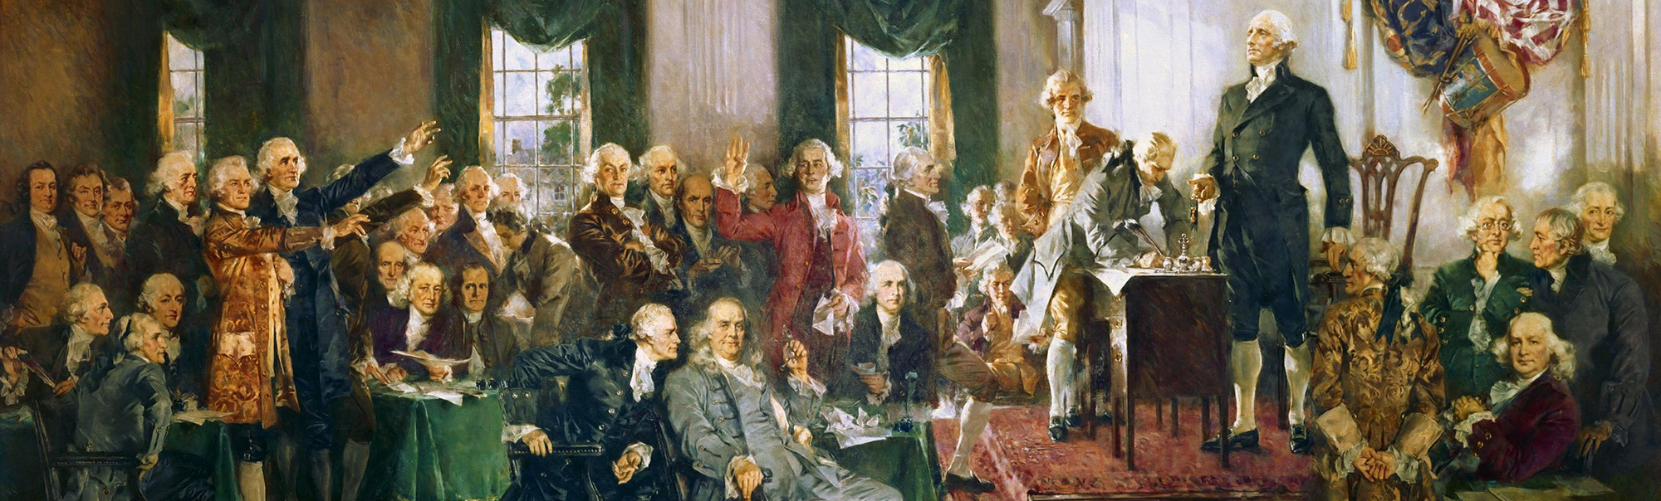
Course Assignments and Grading:
Assessments: 70%
- Tests
- End of Year Capstone Project
- DBQs (Document based argumentative essays)
- LEQs (Argumentative essays without any provided documents)
Classwork: 30%

IMPORTANT: One major classwork assignment each week is graded based on the quality of your work. All other days of the week count under a weekly classwork grade for attendance and participation which is based on how much you attend class and complete your classwork. This means that all work completed in class affects your grade. This requires active and positive participation: coming to class on time every day, following norms, contributing to discussions, and supporting yourself and others. If you miss a day of school without a legitimate reason, you must complete the assignment on Google Classroom or your grade will quickly drop.
- How will you make sure that you complete the course assignments?
→

Citation Guidelines:
When referencing or citing sources, whether primary or secondary, you must adhere to the following citation guidelines. Stating “In Document 1, we see that…” is not citing a source. Citing a source requires: the title, the author, and year of publication. Therefore, the non-citation of “In Document 1…” becomes “In Thomas Paine’s pamphlet, Common Sense (1776), we see that…”. The reason for doing this is so that anyone is able to understand your writing and know which sources you are using to support your argument as opposed to the ambiguous, mysterious, and obscure “Document 1”.

Source: Abigail Adams, Remember the Ladies (1776)
- How do you cite the source above following the course guidelines?
→

Academic Integrity Statement:
By participating in this course, you assume the responsibilities of being an active participant in Discovery’s scholarly community in which everyone’s academic work and behavior are held to the highest standards of honesty. Cheating, fabrication, plagiarism, the use of artificial intelligence, and helping others to commit these acts are all forms of academic dishonesty. Any act of academic dishonesty will result in a zero for the respective assignment(s). Continued and repeated academic dishonesty will result in a reevaluation of your placement in the course.

- Why is it important to not cheat, fabricate, plagiarize, or use A.I. to complete your classwork and essays?
→

Accessibility Statement:
This course is intentionally difficult and designed to challenge your reading, writing, and critical thinking skills. I recognize that every student learns differently, and it is my goal to make this course as accessible and supportive as possible for everyone. If at any time you encounter difficulties with the content or have concerns about your ability to succeed in the course, please do not hesitate to reach out to me. I am committed to working with you to find solutions, whether that means providing additional guidance, offering alternative resources, or discussing accommodations to support your learning.

You can contact me directly at ctaylor@discoveryhsbronx.org or through Jupiter, and I will make every effort to respond promptly. I also encourage you to speak with me early rather than waiting until challenges become overwhelming. This classroom is a space where all students are encouraged to ask questions, share ideas, encourage each other, and engage deeply with the material.
- How can Mr. Taylor help you meet the college-level expectations of this course?
→

Course Schedule & Topics:
Unit One: Indigenous America and the Atlantic World (1492-1607)
Unit Two: North American Colonial Societies (1607-1754)
Unit Three: The American Powder Keg (1754-1789)
Unit Four: Building a Republic (1789-1828)
Unit Five: Democracy, Capitalism, and Reform (1828-1848)
Unit Six: West, North, and South on the Road to the Civil War (1848-1861)
Unit Seven: The Civil War (1861-1865)
Capstone Project
Presentations and Review
- Based on this brief course schedule, which unit are you most looking forward to? Why?
  - You can find a more detailed course schedule in the syllabus if you would like more information about the units and topics covered in this course.
→

Task 1: How can you be successful in AP U.S. History, Part One?
- Include at least two references to:
  - Course Assignments and Expectations
  - The Citation Guidelines, Academic Integrity statement, and Accessibility Statement
- Explain why following these guidelines is important for your growth as a student.
→

Task 2 (Homework): Return The Sheet Attached To The Syllabus by the End Of The Week.
This is includes the:
- Personal Survey
- Course Expectations Agreement

